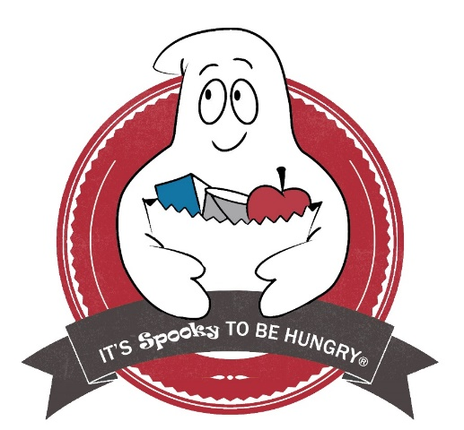
It’s Spooky To Be Hungry is a food and funds drive that is held in many businesses throughout the CSRA during the month of October. Again this year we are giving the Business Community the opportunity to participate in our Spooky Competition. The competition will allow businesses of all sizes to compete and win Spooky Awards. There will be a small, medium and large business winning category.

How does it work?
The Business picks an employee to be the Spooky Representative. They then decide if they want to collect funds, food or both. We have an online virtual food drive that can be utilized for monetary donations. We will send them the competition guidelines

When is the Collection?
October 1st – 31st
What do I need to do to participate?
Sign up the Business by filling out the online registration form. Do it early to get the bonus points!

Where do I get the materials?
Golden Harvest Food bank has a media kit available where you will find the materials necessary for your collection It is available on www.Itsspookytobehungry.org

For additional information please contact: Melissa Brown mbrown@goldenharvest.org
Carrie Jones cjones@goldenharvest.org

