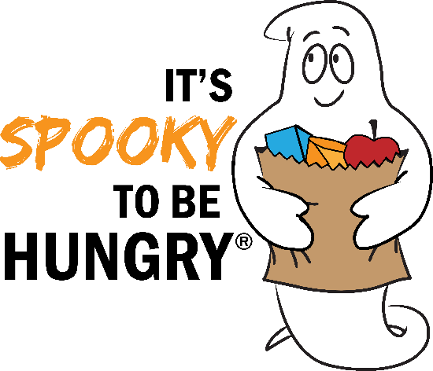
Email Templates
SAMPLE EMAIL TO YOUR TEAM MEMBERS

Hi Team,

We are participating in the “It’s Spooky to be Hungry Campaign” with Golden Harvest Food Bank to raise food and funds to feed the hungry during the holidays! Whichever company raises the most food & funds will be awarded the Spooky “Spirit of Giving” award. There will be winning categories for the different size companies. We want to win the Spooky award – and we need EVERYONE in the office to help us reach out goal!
It’s really is ‘SPOOKY’ how big this problem is: 1 in 6 of our neighbors live in households that can't regularly put food on the table. Golden Harvest Food Bank works 365 days a year to make sure our local soup kitchens and pantries have the food needed to supply our community. It takes a lot to meet the need, but this is our chance to make a difference. Everything we raise will stay local and benefit our community.
This is an excellent investment – with every $1 donated to Golden Harvest, they can distribute the equivalent of 3 meals worth of food into our community. Let's rise to the challenge and do our part to reduce hunger during the holiday season! Share with everyone - friends, family, and clients! This is everyone’s fight!

Donate Here: <Insert link to your company’s online food drive page.>
Sincerely,
Name

SAMPLE EMAIL TO YOUR CLIENTS AND FRIENDS

Dear Client/Friend Name,

We have joined Golden Harvest Food Bank for the Annual “It’s Spooky To Be Hungry Campaign,” a four week food and funds drive competition among the CSRA’s leading local businesses. We are competing this year, and are hoping your company will partner with us!
We want to win the competition, but most importantly we want to provide vital assistance to our neighbors in critical need.

It’s really SPOOKY how big this problem is: 1 in 6 of our neighbors live in households that can’t regularly put food on the table. Here’s how you can partner with us to do something about it:
• Have your company pledge to match monetary donations –
• During October 1st – 31st share (link to your online food drive) with your employees and contacts!
• Have your company hold a food drive of non-perishable items, and deliver the items to Golden Harvest by November 8th.

Everything we raise will benefit Golden Harvest Food Bank. We have a chance to make a REAL impact. For every $1 donated, Golden Harvest Food Bank can distribute the equivalent of 3 meals worth of food into our community.
Let's rise to the challenge and do our part to reduce hunger this holiday season!
Sincerely,
Name

