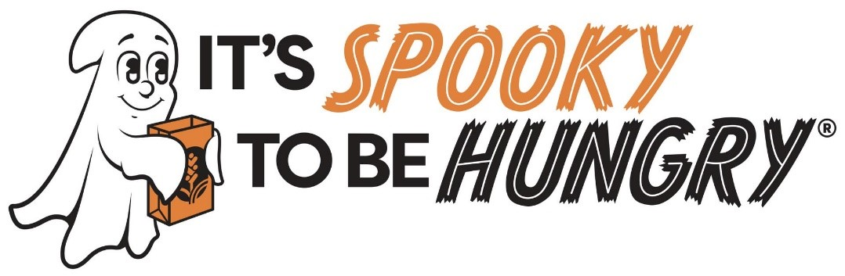
Business Competition Guide

Welcome to the 2026 It’s Spooky to be Hungry campaign! We are excited to link arms with you to feed the hungry. We appreciate you and are here to help every step of the way. As your Golden Harvest Food Bank contact, you can reach me anytime:

Contact
Doressa Hawes, Director of Corporate Partnerships & Volunteerism
Office: 706-736-1199 ext. 127
Cell Phone: 706-495-4478 (call or text)
Email: dhawes@goldenharvest.org

Key Dates
- August 3 – Registration Opens
- September 11 – Early Bird Registration Deadline
- September 16 at 10am – Virtual Business Team Captain Orientation
- September 17 at 12pm – Business Team Captain Orientation Lunch
- October 1 – Campaign Opens
- October 31 – Campaign Closes
- November 5 – All Donations Due
- November 17 – Spooky Celebration and Winners Announced

Next Steps for Business Captains
- Fill out the registration form and create a virtual food drive for your business at itsspookytobehungry.org.
- Mark your calendar for the Business Captain Orientations to learn more.
  - September 16 at 10am (virtual)
  - September 17 at 12pm (in-person with lunch provided)
- Start spreading the word and planning ways to engage your coworkers.

Your Role as a Spooky Business Captain
You have a central role in promoting the competition to your colleagues, clients, friends, and family. Make sure they know the rules, how to donate, and why it’s important! Find creative ways to raise funds for your business team. You can view our Scare Away Hunger Toolkit online for more ideas. Don’t forget to stay in touch. We’re here to help!

What is “It’s Spooky to be Hungry”?
It’s Spooky to Be Hungry is one of the nation’s most successful grassroots food drives, held annually in the CSRA. Each year, businesses, schools, and neighborhoods come together during this spirited campaign to help feed families in need.
The name reflects a sobering truth: 1 in 6 of our neighbors—and 1 in 4 children—struggle with hunger. That’s a scary reality we’re committed to changing.
With your support, over 1 million meals will reach tables across our 24-county service area, bringing hope and nourishment to those who need it most. By joining the campaign, you're not just collecting food and raising funds; you’re building a stronger, more compassionate community.

Ways to Participate
Traditional Food Drive
Ask your colleagues, clients, friends, and family to donate nonperishable food items. You may use your own food collection containers or pick one up from our Augusta or Aiken Warehouse during regular business hours. You can request a Spooky bin for your food drive when you register. If you would like to use your own containers, sturdy, plastic bins work well.
Please note: Due to limited staff and trucking resources, along with the growing need to serve neighbors across our 24-county service area, Golden Harvest Food Bank is no longer able to offer item pick-up or delivery.
- Augusta Warehouse: 3310 Commerce Drive Augusta, GA 30909
- Aiken Warehouse: 81 Capital Drive, Aiken, SC 29803
- Drop Off Hours: Monday-Friday 8:00am-4:00pm
- Closed for Lunch from 12:00pm-1:00pm

Donate through your Business’s Online Virtual Food Drive
Visit www.itsspookytobehungry.org to create your business's virtual food drive. Once you’ve created your team, you can copy and paste your link to share with others. Remember, every $2 raised is worth 5 points toward your goal.
Donating by Check
Checks should be made payable to Golden Harvest Food Bank. Make sure the memo line has “Spooky” or “It’s Spooky to Be Hungry” and your company’s name! Checks can be turned in with your food collection at one of our warehouses or mailed to our Augusta Warehouse.
All online donations count as delivered. All mailed donations must be received by Golden Harvest Food Bank by November 5 to count toward your campaign totals.

Competition Rules
Only food and funds collected between October 1-31 will count toward the competition. The business earning the highest number of points will win the Spooky award for their business size category in Georgia or South Carolina.

Scoring
- 1 pound of food = 1 point
- $2 = 5 points. Why is that? Because Golden Harvest Food Bank can distribute 5 meals for every 2 dollars you donate!

Bonus Point Opportunities
- Early Bird Registration Bonus: Register by September 11 for 200 Bonus Points.
- Orientation Bonus: Attend a Business Team Captain Orientation for 300 Bonus Points.
- Delivery Bonus: Deliver your donations by November 3 for a 200 Point Bonus.
- Challenge Bonus: Challenge your neighboring businesses or fiercest competitor to start a team. If they do, let us know, and you’ll get 100 Bonus Points!
- Tag Bonus: Tag Golden Harvest Food Bank and use #itsspookytobehungry, #scareawayhunger, and #neighborsfeedingneighbors. Send a screenshot of one (1) post to Doressa Hawes at Dhawes@goldenharvest.org, and you’ll get 200 Bonus Points!
- Special Event Bonus: Host a special event or workplace competition to raise money. See our Scare Away Hunger Campaign Toolkit for ideas! Share the results with us. Put the proceeds toward your goal and earn another 300 Bonus Points!

Spooky Celebration and Awards
Mark your calendar for November 17! Join us for a celebration to honor our winners and participants in the 2026 It’s Spooky to Be Hungry Campaign. Winners will be announced in each category:
- Small Business Georgia/South Carolina
- Medium Business Georgia/South Carolina
- Large Business Georgia/South Carolina
- Small Neighborhood Georgia/South Carolina
- Medium Neighborhood Georgia/South Carolina
- Large Neighborhood Georgia/South Carolina
- Rural Neighborhood Winner
- School Winner Columbia County
- School Winner Richmond County
- School Winner Aiken County
- Agency Partner Georgia/South Carolina
- Community Winner Georgia/South Carolina
- Outstanding Partner
- Outstanding Youth Partner
- Evelyn Browne Spirit Award

